# JUnitTest results

## Server

networkAddressRange.java

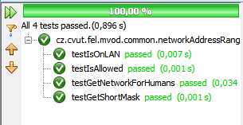

XMLFactory.java

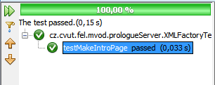

XMLParser.java

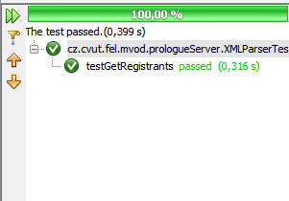

registeringHandler.java

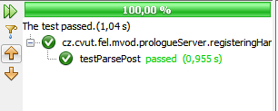

webPageLocalizer.java

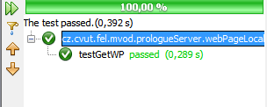

## Andoid

XMLParser.java

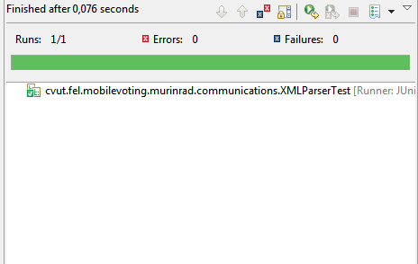

XMLMaker.java

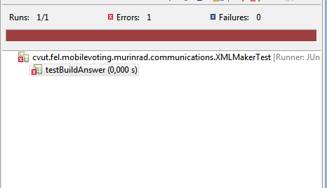

The XMLMaker uses Android libraries that cannot be run outside the Android device. Therefore, it fails when using JUnitTest